Hooking up the CMUcam2 to the Vex controller

It’s fairly easy to get a CMUCam operating on a Vex platform. For software, Kevin Watson (http://kevin.org/frc/), originally developed his CMUCam communication code on an EDU controller. It's a pretty simple transition if you want to port existing FRC code over to the Vex.
This wiring does not support running the servos from the CMUcam2 board. Additional voltage is required over and above the 5v available through the Vex controller. If you decide to do this then instead of taking power from the Tx/Rx 5v pin you’ll need to take power directly from the 7.2v battery source.
The Vex programming port will serve just as well if you prefer and you can even run two cameras easily. Running more than two cameras simultaneously can be done, either through software by converting digital I/O pins to software serial ports, or hardware via an external processor with more USART capabilities.
- Male-to-male PWM-style cables are needed (purchase, combine old cables, purchase male-male connectors, or make your own).
- Camera power can come from any +5v pin on the Vex controller (all the middle pin positions). Use a regular male-to-male PWM cable.
- Serial communication is simplest from the native CMU TTL port to the native Vex TTL port. It’s cleanest with a 4-pin housing at the camera end, but you can rig a solution from a pair of 3-pin connectors or a 3-pin/single un-housed pin combination too. The Vex end needs two side-by-side connectors, because the Vex TX/RX pins are themselves side-by-side.
  - Carefully note the location of each TTL port pin in Thumbnail 2 and avoid the CMUcam2 TTL port power pin, so you’ll need a 4-pin connector with the third pin missing.
  - Note the Tx of one device is connected to the Rx of the other, so:
    - Ground-to-ground
    - CMU Rx to Vex Tx
    - CMU Tx to Vex Rx
- See Thumbnails 1 & 3 for photos of the wiring. Note however that the green Rx wire leaving the CMUcam2 arrives at the Vex controller as a white wire, because I added a male-to-male cable. I made sure you can see the Tx/Rx labels where numbers normally are in Thumbnail 3.

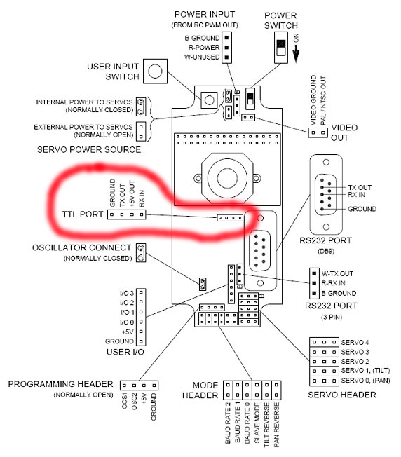
Figure 1: CMU camera board TTL port

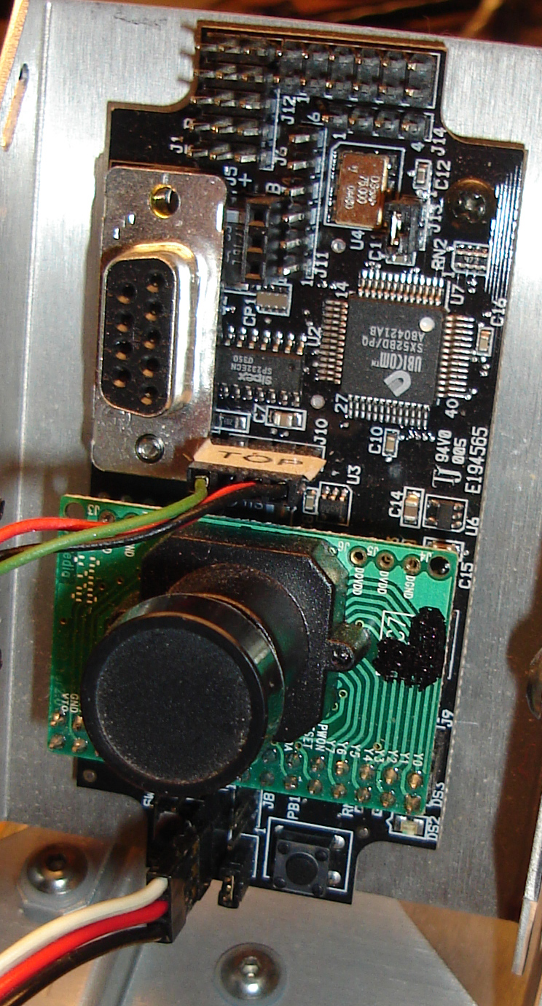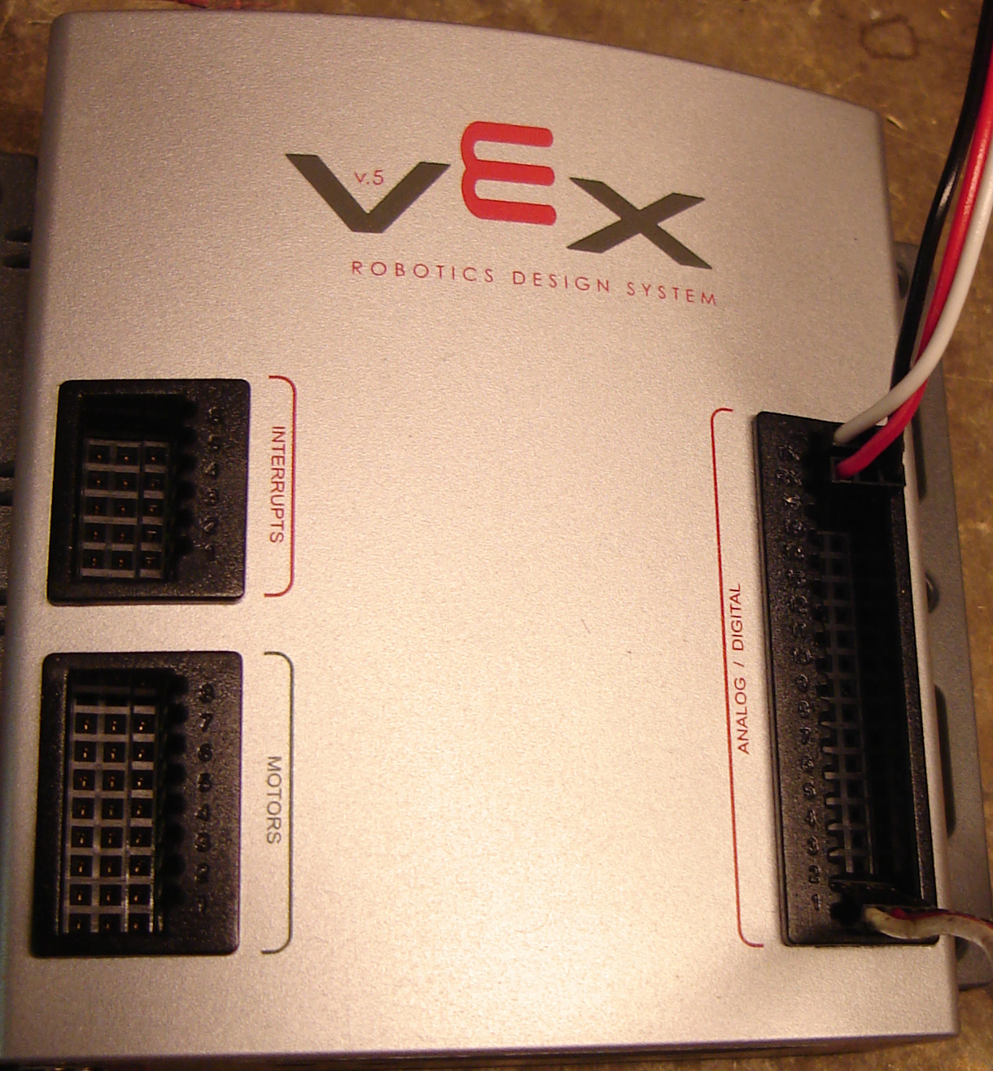
Figure 2: CMU Wiring Figure 3: Vex Wiring(note green is now white)

